ASPERGERS & HIGH FUNCTIONING AUTISM
ASPERGER’S & HIGH FUNCTIONING AUTISM
Training by Tony Attwood
25-26 November 2016
India International Centre, New Delhi, India
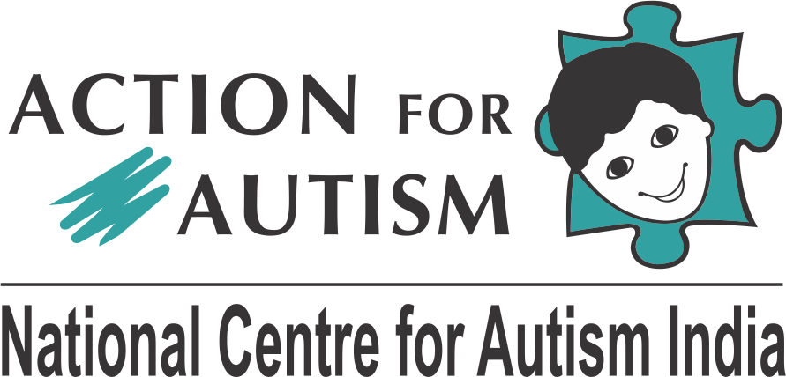

Professor Tony Attwood is recognized internationally as the leading specialist in Asperger’s Syndrome and High Functioning Autism and has worked with many thousands of individuals of all ages. Prof Attwood presents workshops; runs training programmes for parents, professionals and individuals with Asperger’s and High Functioning Autism; and is a keynote speaker at conferences all over the world. He is adjunct professor at Griffith University, Queensland and senior consultant at the Minds and Hearts Clinic in Brisbane. Prof Attwood has authored several books including the iconic Asperger’s Syndrome – A Guide for Parents and Professionals, which has sold over 350,000 copies and has been translated into over 25 languages. His subsequent book, The Complete Guide to Asperger’s Syndrome, is one of the primary textbooks on Asperger’s syndrome.

The training will focus on issues across the lifespan, especially strategies to –
- Make friends
- Improve social understanding and relationships
- Reduce being bullied and teased
- Build upon cognitive abilities
- Manage feelings and facilitate emotion management
- Sustain employment

Contact –
Coordinator, Trainings
Action For Autism, Pocket 7 & 8 Jasola Vihar, New Delhi 110 025, India
Email: anvay.trainings@gmail.com
Ph: +91 73847 84346; +91 11 4054 0991-92
URL: www.autism-india.org
TRAINING BY TONY ATTWOOD
25-26 November 2016 (Friday-Saturday); 9:00 am – 5 pm
Seminar Hall 1 & 2, India International Centre, New Delhi, India
REGISTRATION FORM
This is a fillable form. Click on the grey boxes to enter information. Press ‘tab’ to move between items. Alternately, print and fill the form with a pen.
Please use BLOCK LETTERS. Attach a copy of your demand draft / online transaction receipt. Keep a photocopy for your records.
Person with Autism | Parent | Professional | AFA Membership No:
 |  |  | ^{(If Applicable)}
PERSONAL INFORMATION
Prof Dr Mr Ms |  |  | First Name: |  | Last Name:
Father Spouse |  |  | First Name: |  | Last Name:

Residential Address:
State: |  |  | Country: |  | Pin Code:
Email: |  |  |  |  | Contact No:
Organisation Name: |  |  |  |  | Designation:

Organisation Address:
State: |  |  | Country: |  | Pin Code:
Email: |  |  | Website: |  | Contact No:

REGISTRATION DETAILS (Check as Applicable)
Registrations (Persons with Autism) |  |  |  |  | INR 2,500 USD 50
Registrations (Parents / Professionals ) |  |  |  |  | INR 15,000 USD 285
Spot Registrations (Subject to Availability for everyone) |  |  |  |  | INR 20,000 USD 400
10% Discount (if applicable) |  | Parent Couple |  | 5 or More professionals (from the same organisation)

Total Amount:
Payable Through: |  | Online Bank Transfer |  | Demand Draft (in favour of ‘Action for Autism’ payable at New Delhi)
Online Transaction/Demand Draft No: |  |  |  | Dated:

Drawn On Bank:
Receipt in Favour of: | Full Name: |  |  | PAN No: (Must be of the same individual/organisation )

I understand and accept that:
- Registration includes reading material, lunch and refreshments.
- A copy of receipt / demand draft / online transaction receipt is required along with this form.
- A copy of student identification card is to be attached along with this form, if applicable.
- Incomplete registration forms or forms not accompanied with the contribution towards registration will not be processed.
- Registration is non-refundable. It will not be possible to adjust the contribution towards registration against other services at AFA.
- If applicable, either parent or professional discount on registration may be availed.
- Demand draft may be drawn in favour of ‘Action For Autism’ payable at New Delhi. Cheques or debit/credit cards are not accepted.
- Online bank transfer: Beneficiary: Action For Autism Bank: Vijaya Bank, Defence Colony, New Delhi, India
SWIFT No: VIJBINBBDCD IFSC Code: VIJB0006005 MICR Code: 110029007
Savings A/C No: Within India Transactions: 600501010009008 Oversees: 600501550010210

Completed forms may be delivered to: Trainings Coordinator, Action For Autism, The National Centre For Autism, Pocket 7 & 8, Jasola Vihar, New Delhi 110 025.
Signature

